ECSAT NEWSLETTER JANUARY 2017
Season’s Greetings to all our funders and supporters
We welcome back our Programme Director from his Fellowship in US
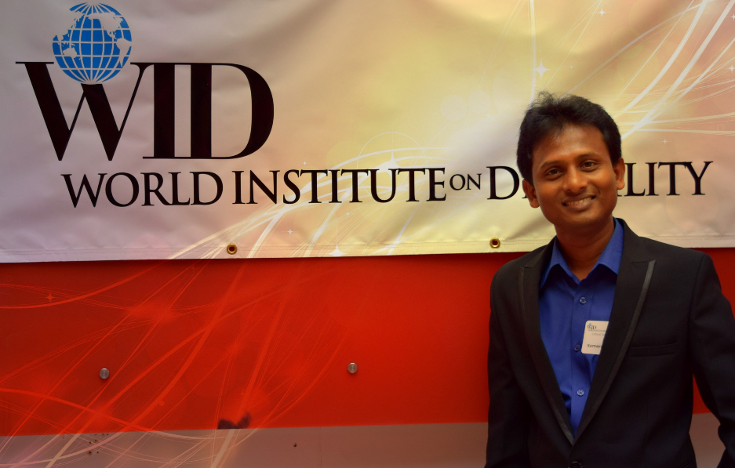
Roshan was one of 97 leaders from 37 countries who participated in the prestigious Community Solutions Programme in 2016 in the U.S. His host organisation was World Institute on Disability WID in California. During his 4 month fellowship he learnt about many strategies, which are not available in Sri Lanka, for working with disabled people. He was particularly interested in animal therapy, new ways of supporting autistic and hyperactive children and accessibility for people who are wheelchair bound. It was an opportunity to network with fellows from other countries, attend trainings and interact with local communities. He was invited to give a presentation about ECSAT to WID and the University of Berkeley in California.
Roshan returned in December and thanks his staff for their professional conduct during his absence and their commitment to continuing with the ECSAT projects. They all took on new responsibilities.
Special thanks are due to our Administrator Ayesha who worked up to four days before her baby boy was born. Congratulations to mother and baby. Also Roshan expresses his sincere gratitude Gina Graham – Trustee of FOE UK - who supported with staff on a day to day basis to continue the work in a very professional way.

Sports Meet November 3rd
Over 200 beneficiaries from Galle, 24 from Hikkaduwa and 06 from Bonavista and took part in a Sports Meet at Hikkaduwa Urban Council Ground on November 3rd 2016. Staff and volunteers arrived early to clean the ground, bring chairs, set up the huts for the teams Feather and Pearl, arrange the stage, fix the sound system, connect the water bowser and mark out the cricket pitch. Staff wore the dress code of blue T-shirt with blue trousers and beneficiaries wore white T-shirts with black trousers.
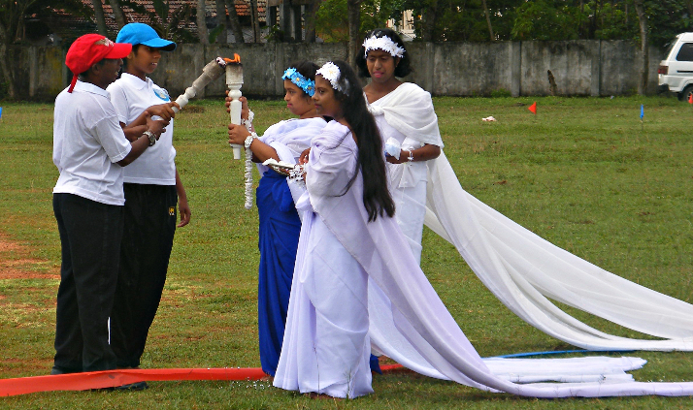
The Sports Meet opened with lighting the Olympic Torch
The first event was a game of cricket between the teams Pearl and Feather. This was followed by a varied programme including running races, obstacle race, relays, bucket and ball, pass the teddy, wheelchair race, long jump and shot putt. Winners were presented with medals and certificates by different sponsors. The day finished with an impressive drill display by the children.
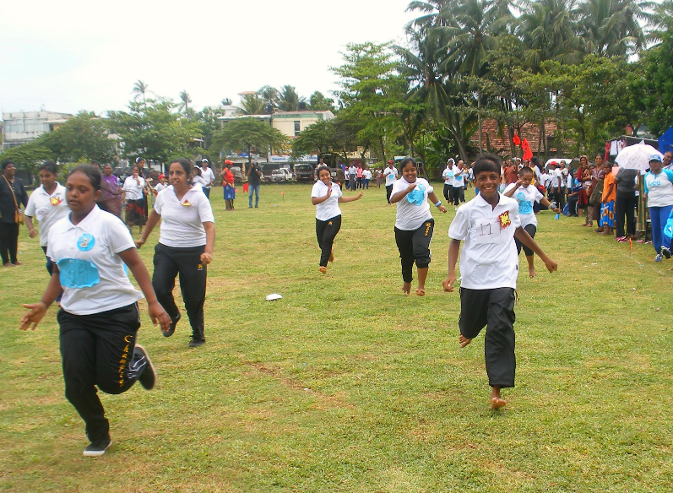
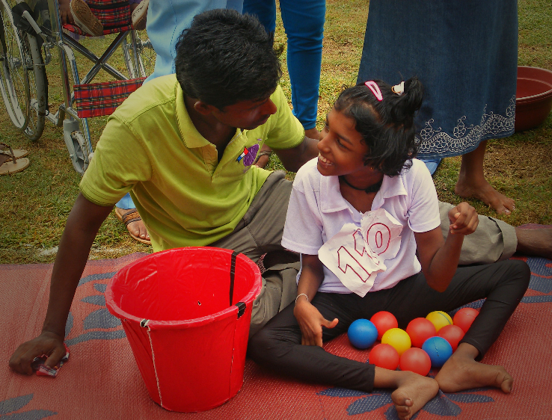
Parents and the local community came together to make an enjoyable and successful day for everyone.

Snapshots of Some of our Programmes
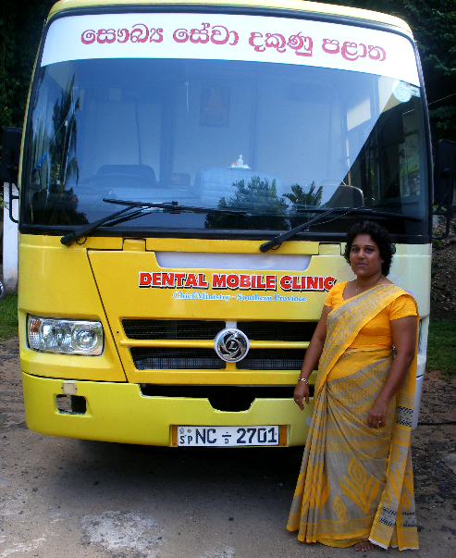
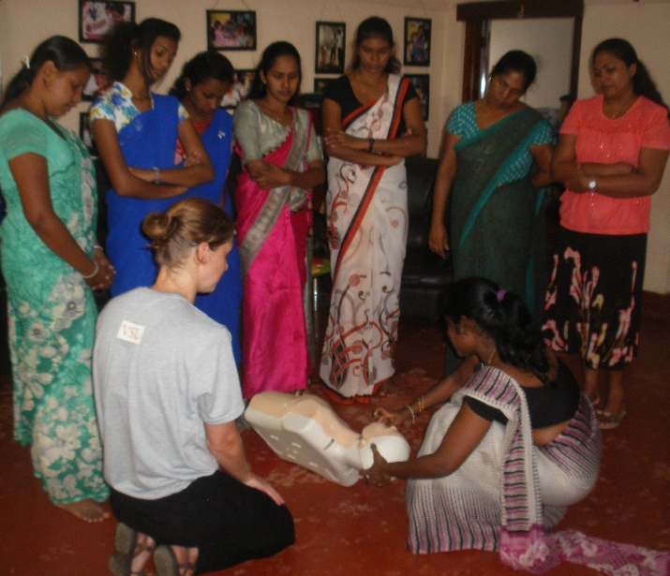
Dr. Jo from Volunteer Sri Lanka gives Our therapist Kumari organised
CPR training to staff a visit from the mobile dental clinic
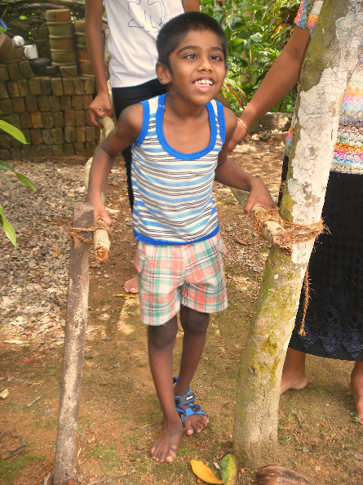

World Children’s Day in October
Fathuma is having painted butterflies
Ravindu is walking using
parallel bars in his garden

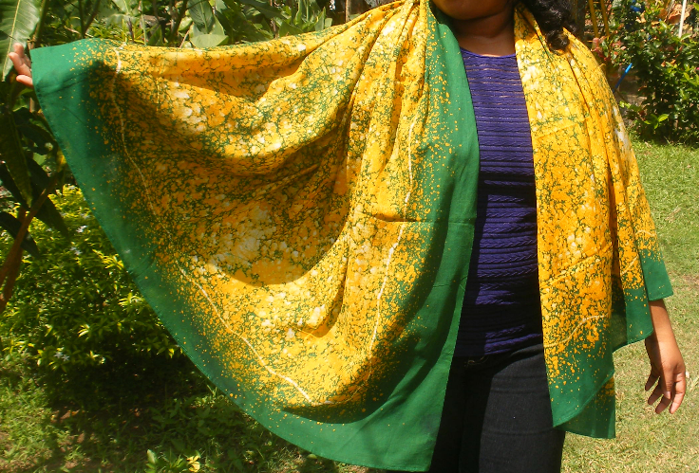
Check out our new range of batiks - long scarves - on ebay

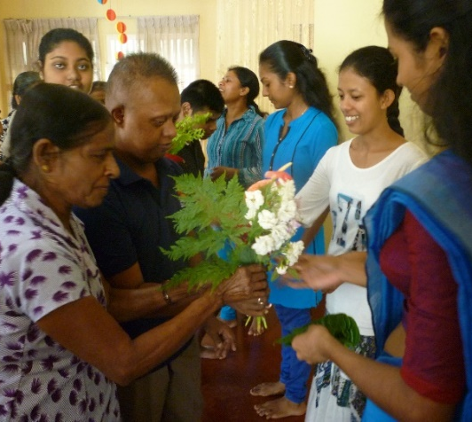
News from the Matara Centre
On October 6th the children and parents celebrated World Teacher’s Day and presented teachers with betel leaves and bouquets designed and made by the children.
In November, staff organised a Fruit Day with activity groups of apple, orange, banana and mango. The children learnt the colour and taste of each fruit and made a fruit salad which was enjoyed by everyone.
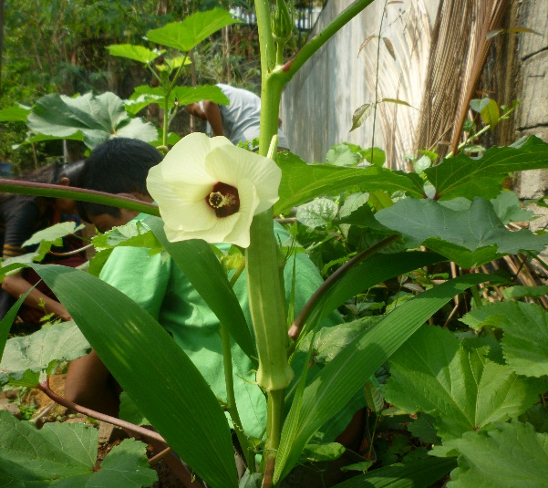
On 29th November, 32 parents attended a parents meeting where they were able to express their gratitude to the staff and discuss issues such as attendance, cleaning the premises and children’s record books.
The Vocational Training group started making paper bags from waste paper as a way of earning a small income. Every morning the group looks after the garden and takes a pride in the colourful displays.

A big THANK-YOU...
... to all of you – our supporters and friends – who have made ECSAT’s work possible!
We will send you another newsletter soon to keep you up to date with all of our news.

Keep in touch
Check our website www.ecsatlanka.org
Join us on Facebook www.facebook.com/ecsat

Support ECSAT:
regular & one-time giving

Your donations make a huge difference to the lives of poor and vulnerable people in Sri Lanka. Please help support our work by making a one-off or a regular donation.

Donate online at www.ecsatlanka.org/support

Or set up a regular or donation to our bank:

Sri Lanka: ECSAT Bank name and branch: Commercial Bank – Galle Fort
Account number: 1107585301
SWIFT CODE: CCEYLKLX

UK: Friends of ECSAT
Bank name: HSBC
Account number: 01858920
Sort Code: 40-09-18

If you would like to donate in the UK using Gift Aid we will be able to claim the tax back, increasing the value of your donation by 28%. Please visit www.ecsatlanka.org/support for more information.

Keep in touch
ECSAT Community Support Centre, 288/4 Singhepura, Wackwella Road, Galle, Sri Lanka
Tel: +94 912248475 (Centre)
Tel: +94 773489222 (Programme Director)
Email: ecsatlanka@gmail.com
NGO number: L-105104

A Big Thank You to our current sponsors.
Australia High Commission
British Asia Trust
Feminist Review Trust
Friends of ECSAT
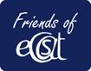
Kindermission
Meriel Peain
Rotary Club Colombo
Saramanda Lanka
Sarath and Mangala Joshua
Hemasiri Vithana
Roshanara Dias

