ECSAT NEWSLETTER JANUARY 2016

Happy New Year and Best Wishes for 2016
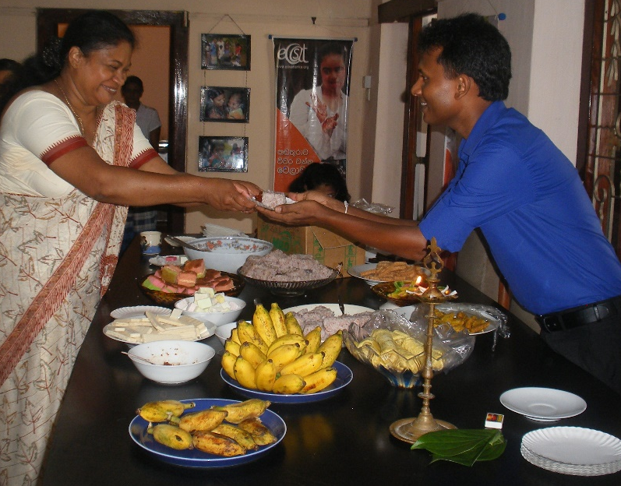

Ayubowen

Our Programme Director Roshan is welcoming Renuka, a new member of staff. Renuka is our new vocational trainer.

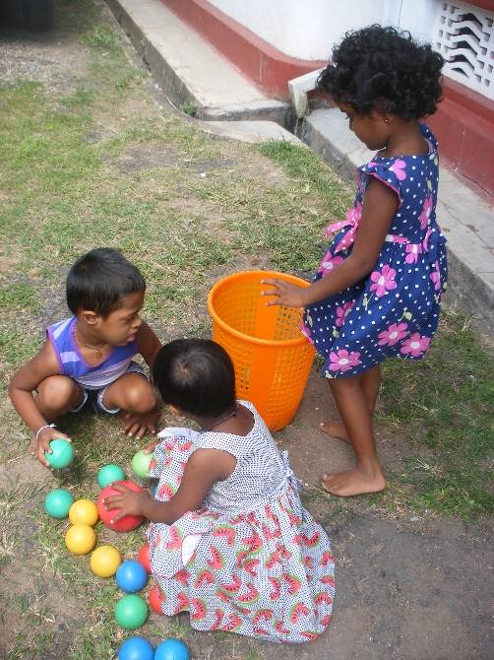
OUR NEW PRE-SCHOOL
On January 11th our new pre-school opened its doors to seven disabled children. These children had been denied access to pre-schools in their area due to discrimination against disability. Two members of staff run the pre-school and have both recently qualified with a Diploma in Special Education. The pre-school will run classes for up to 15 children and have sessions four mornings a week.

Snapshots of Some of our Programmes
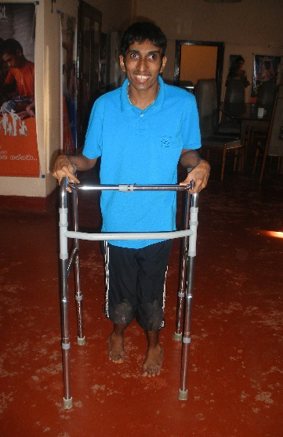
Physiotherapy
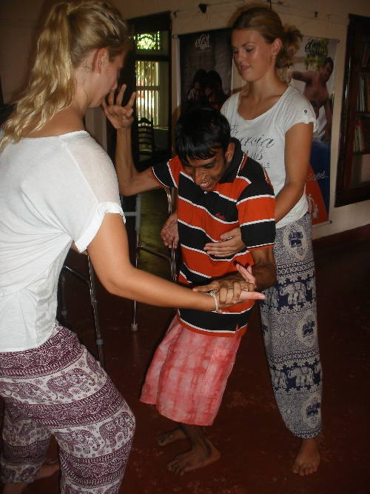
Kalum has cerebral palsy and walks with a walking frame. He travels to the Centre in a tuk tuk and has to be lifted in and out by the driver. Two volunteer physiotherapists from the Netherlands came every day for several weeks to encourage him to stand on his own. These exercises are being continued by our own staff who have noticed an improvement in the strength of his legs.

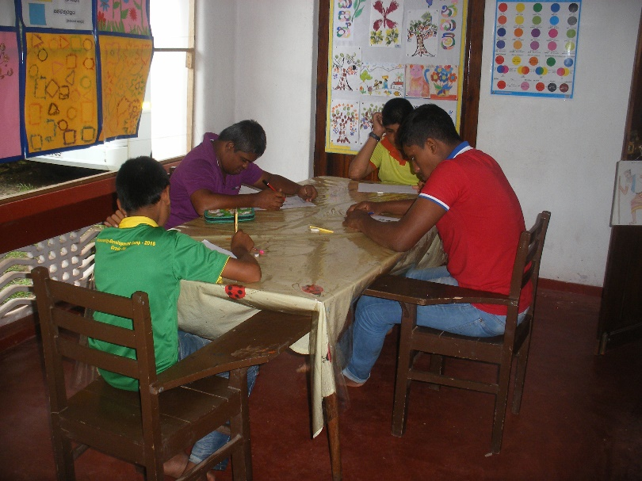
Term Tests
Term tests are conducted three times a year and the results indicate which beneficiaries can be referred to government schools.
Eight children were referred to local schools in 2015.
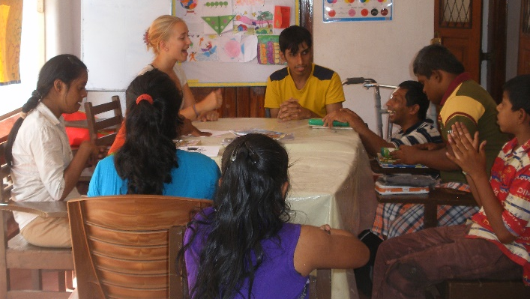
Education Classes
Merieke was from Volunteer Sri Lanka and engaged with the beneficiaries teaching English through songs and art and craft activities.
December Programme
ECSAT ran a varied programme of life skills for the school holidays. Activities included the role play of running a home, how to tidy a gardening, basic cooking skills, dance, games, art and crafts, beach activities and an adventure trip.
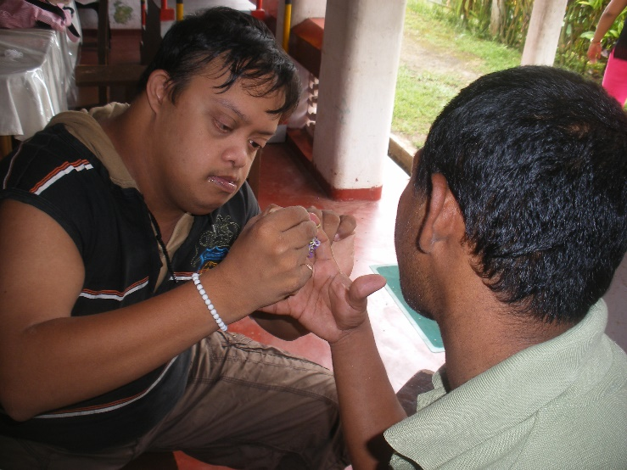
A parent spent one afternoon showing beneficiaries how to link bands together round their fingers to make a friendship bracelet. Here Lahiru is helping Nalaka. This was a fun way to develop fine motor skills.
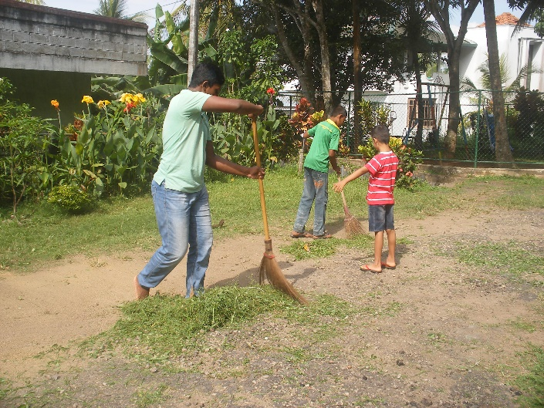

Sweeping and tidying a garden is a daily activity in Sri Lanka. Beneficiaries swept up leaves and took them to the bonfire pile. Flowers borders were weeded and neatly edged with empty coconut husks.
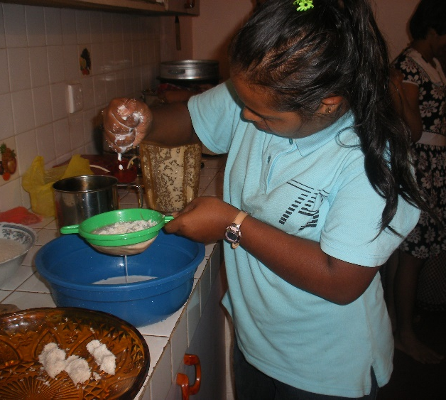
Basic cooking skills were learnt making watalappam. Mixing, stirring, pouring, sieving and cooking were carried out in turns by the beneficiaries. Here Dayathma is squeezing milk out of coconut. Vanilla pods were crushed under a cloth using a molgaha (wooden pestle). Everyone enjoyed the tasting.

A big THANK-YOU...
... to all of you – our supporters and friends – who have made ECSAT’s work possible!
We will send you another newsletter soon to keep you up to date with all of our news.

Keep in touch
Check our website www.ecsatlanka.org
Join us on Facebook www.facebook.com/ecsat

Support ECSAT:
regular & one-time giving

Your donations make a huge difference to the lives of poor and vulnerable people in Sri Lanka. Please help support our work by making a one-off or a regular donation.

Donate online at www.ecsatlanka.org/support

Or set up a regular or donation to our bank:

Sri Lanka: ECSAT
Bank name and branch: Commercial Bank – Galle Fort
Account number: 1107585301
SWIFT CODE: CCEYLKLX

UK: Friends of ECSAT
Bank name: HSBC
Account number: 01858920
Sort Code: 40-09-18

If you would like to donate in the UK using Gift Aid we will be able to claim the tax back, increasing the value of your donation by 28%. Please visit www.ecsatlanka.org/support for more information.

Keep in touch
ECSAT Community Support Centre, 288/4 Singhepura, Wackwella Road, Galle, Sri Lanka
Tel: +94 912248475 (Centre)
Tel: +94 773489222 (Programme Manager)
Email: ecsatlanka@gmail.com
NGO number: L-105104

