Newsletter July 2020
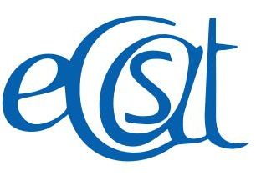

Dear Supporters,
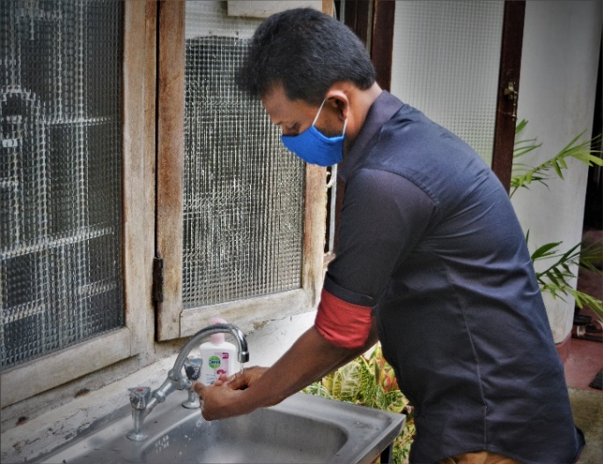
I'm delighted to report that ECSAT's services resumed on 8th June 2020 and we were very happy to open the doors of Galle, Matara and Hikkaduwa Community Centres to beneficiaries and their families. This was greatly helped by funding from Australian Volunteers Program Fund for a ‘Back to Business’ project to provide hand sanitisers, masks and disposable gloves for poor families and hand washing facilities and disinfectant for sanitising and deep cleaning at our three Centres. ECSAT is now able to manage our education, vocational training and therapy services safely and has been approved by the Public Health Inspector. Also, the vocational training team are making masks for sale and the income is used to purchase sanitisers for ECSAT usage during the project and after it finishes.
I am pleased to report we have received funding from the Australian Direct Aid Programme for a new project called ‘Shared Care’ starting in September, for mothers who are housebound with young adults.
In June, I had the opportunity to share many grassroots stories during a Zoom panel discussion with experts in the field of gender, disability and human resources and highlighted the impact of covid-19 on persons with disabilities in Sri Lanka. The panel were touched by the stories and we received a donation which we plan to use for an Outreach project. Also, we are in discussions for setting up mini centres to address the human resource needs of people with disabilities. Due to the covid-19 pandemic I had to return to Sri Lanka in May and shall enjoy supporting ECSAT in my own country before I return to Australia to resume my studies in January 2021.
I hope this newsletter gives you an idea about the work we continue to carry out during these challenging times.

I send my sincere wishes for everyone to keep safe and well.
Roshan Samarawickrama- Programme Director
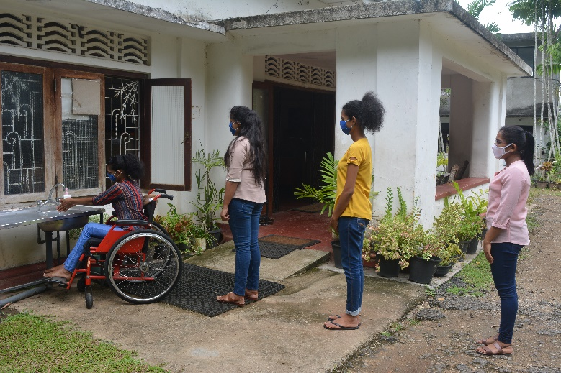
Back to business Project:

Social distancing at handwashing station outside Galle Centre

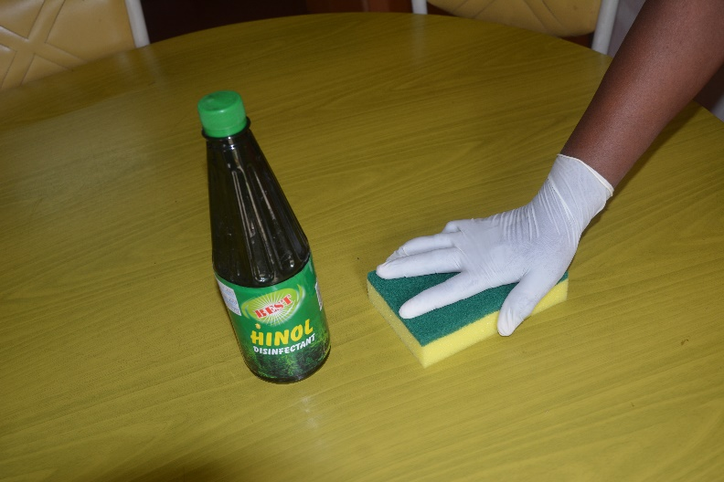

Deep Cleaning
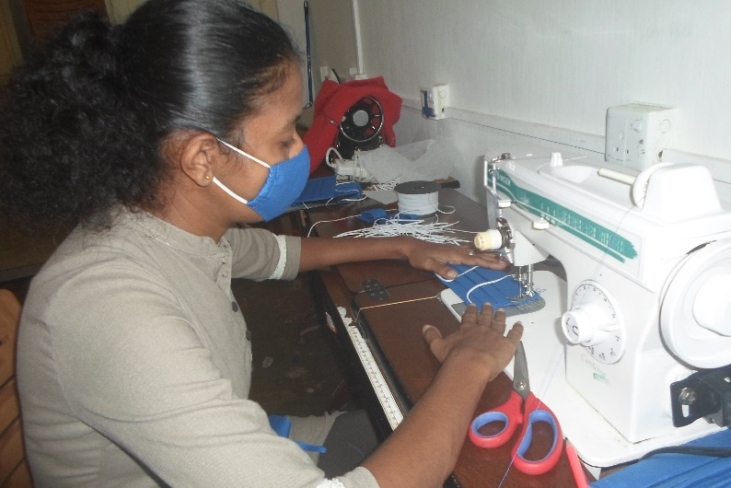

Making Masks

Education Case Study
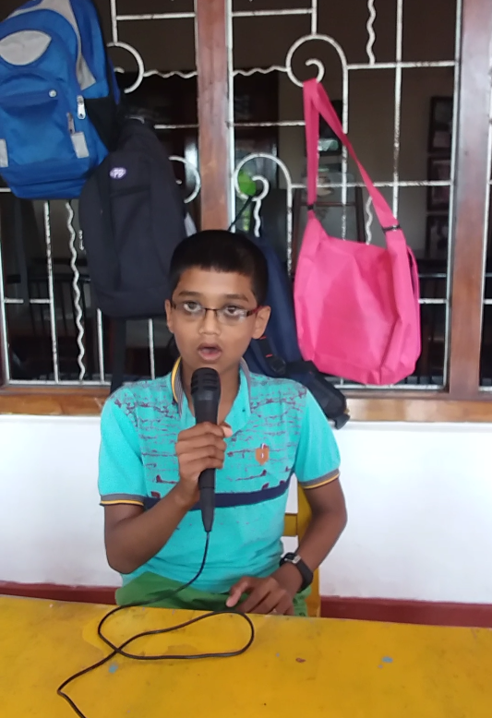
Hansaka is a 13-year-old boy with hypertonia, a form of cerebral palsy, and lives with his parents. His father is a policeman and his mother is a housewife. Sadly, his brother died after an accident. He went to a government school from 7.30-1.30 pm and was unhappy because he found the time too long and the syllabus difficult. ECSAT supported his parents to meet the Education Director and the Special Education Director and reduce Hansaka's hours to 7.30-11.0am. He attends after school classes at Galle Centre four afternoons a week. After ECSAT's initial assessment, the main targets were to improve his social, mobility and numeracy skills. Now he is able to perform a simple speech, sing songs and dance. Hansaka is very pleased and he told us “at the beginning I was afraid to perform anything without other support. Now I can speech myself well. Also I was able to repeat story after the teacher telling story and I love to ECSAT friends.”His parents are very pleased with his progress and the support given by ECSAT. Mother and child received counselling and the mother has joined the vocational unit and production team.
Hansaka singing to an audience

Vocational Training Case Study
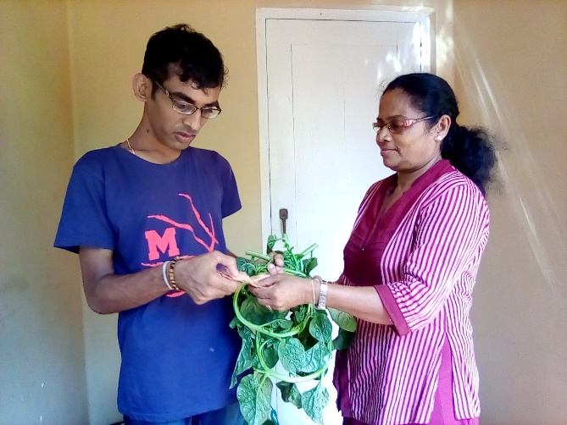
Chanuka is 23 years old and lives with his parents and elder brother. He had attended Rohana special school as a slow learner. In 2016, when he joined Matara vocational unit, he wanted to be alone and was not talkative. After taking part in the different training sessions, he now works very happily with his peers and is class monitor. Chanuka particularly enjoys gardening and making doormats. His parents are very happy with his progress since joining ECSAT and the support he has received with business skills to generate his own income. With support from his parents, Chanuka plans to set up a hardware shop.
Chanuka sells spinach he has grown to parents.

Speech and Language Therapy Case Study
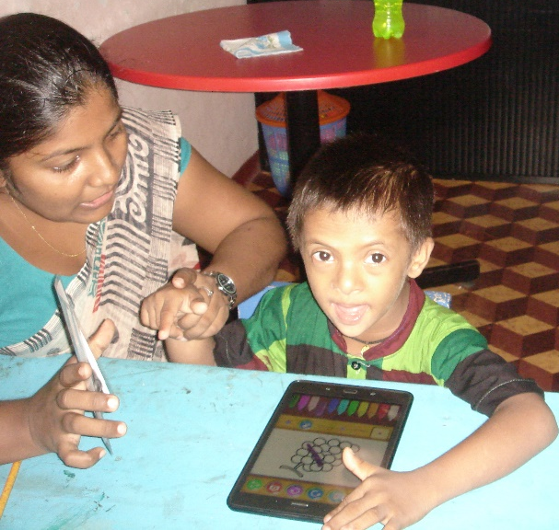
Shanal is a 6 years and 8 months old boy with Downs syndrome diagnosed with communication delay although his hearing and vision are normal. He attends Galle Centre for speech and language therapy. At first he found it difficult to focus on an activity and wait and take turns in a group. He could understand simple commands such as 'stand up' and name a few body parts and fruit but his articulation was poor due to phonological difficulties. Now, after five months of speech and language therapy, Shanal has good oral motor skills such as to protrude and retract tongue, open and close mouth, lateral movement of tongue and jaw. He articulates with good strength and tone, but has limited oral accuracy and movement. His two word level comprehension has improved and he can comprehend two word phrases consisting of noun + verb such as, dog eating, baby drinking. Shanal's social skills have developed and he likes to play and engage with his peers.
Shanal working with the speech therapist

Friends of ECSAT Australia
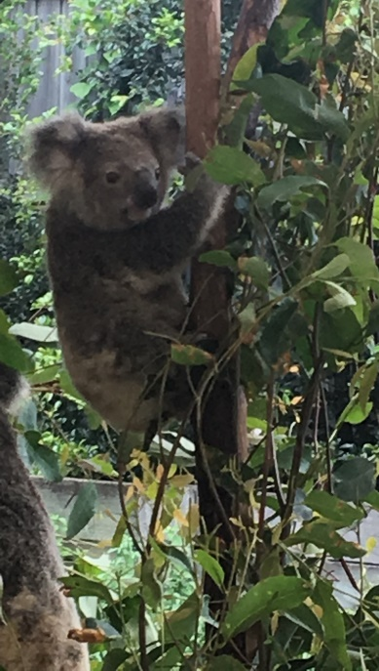
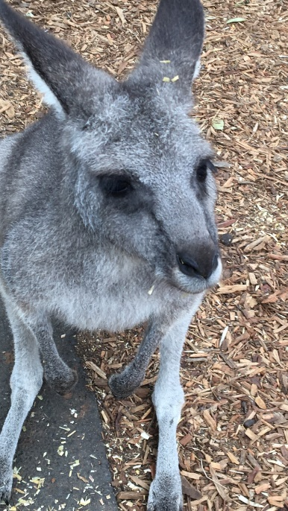
Returned volunteers David Kimber and Fran Siemensma have set up Friends of ECSAT Australia from their home city of Melbourne. They have raised funds to develop the staff capacity, in particular for taking a Diploma in Special Education. They initiated this fund while volunteering at ECSAT.

Thank you blessing to all our supporters.

